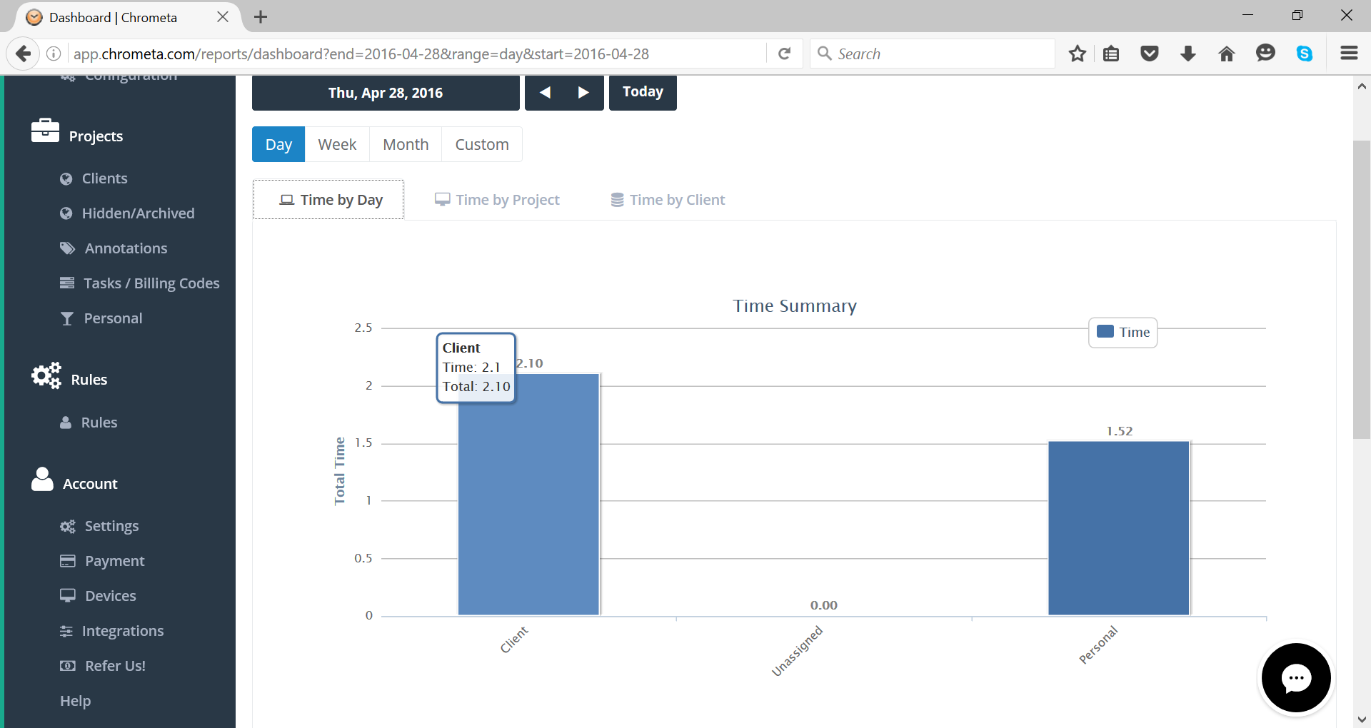
Suggestions to make this view show the client bar split by client with each time and total time. Currently the time and total are the same number with different decimal pts.
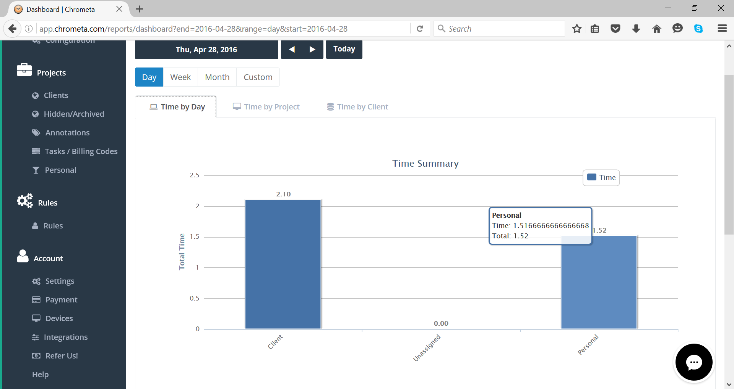
Suggest the decimal points all be consistently rounded to say 2 decimal places.

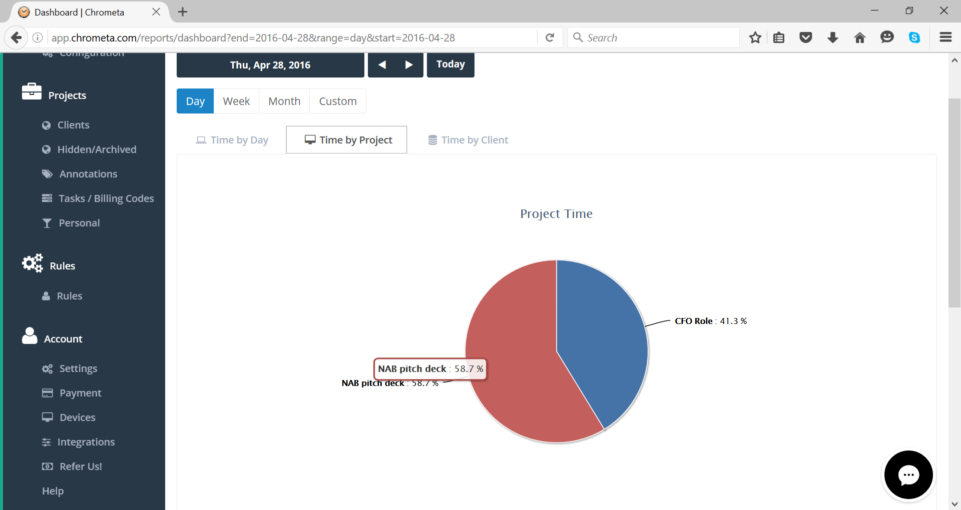
When hovering over suggest the hover adds more information than what is there without it rather than the same information repeated. Perhaps something like hours where it shows % and the hover shows the hours rounded to 2 decimal places. Perhaps even add a client sub text in the hover ? Just in the even there are more than a few projects and easier to see which client on the same.

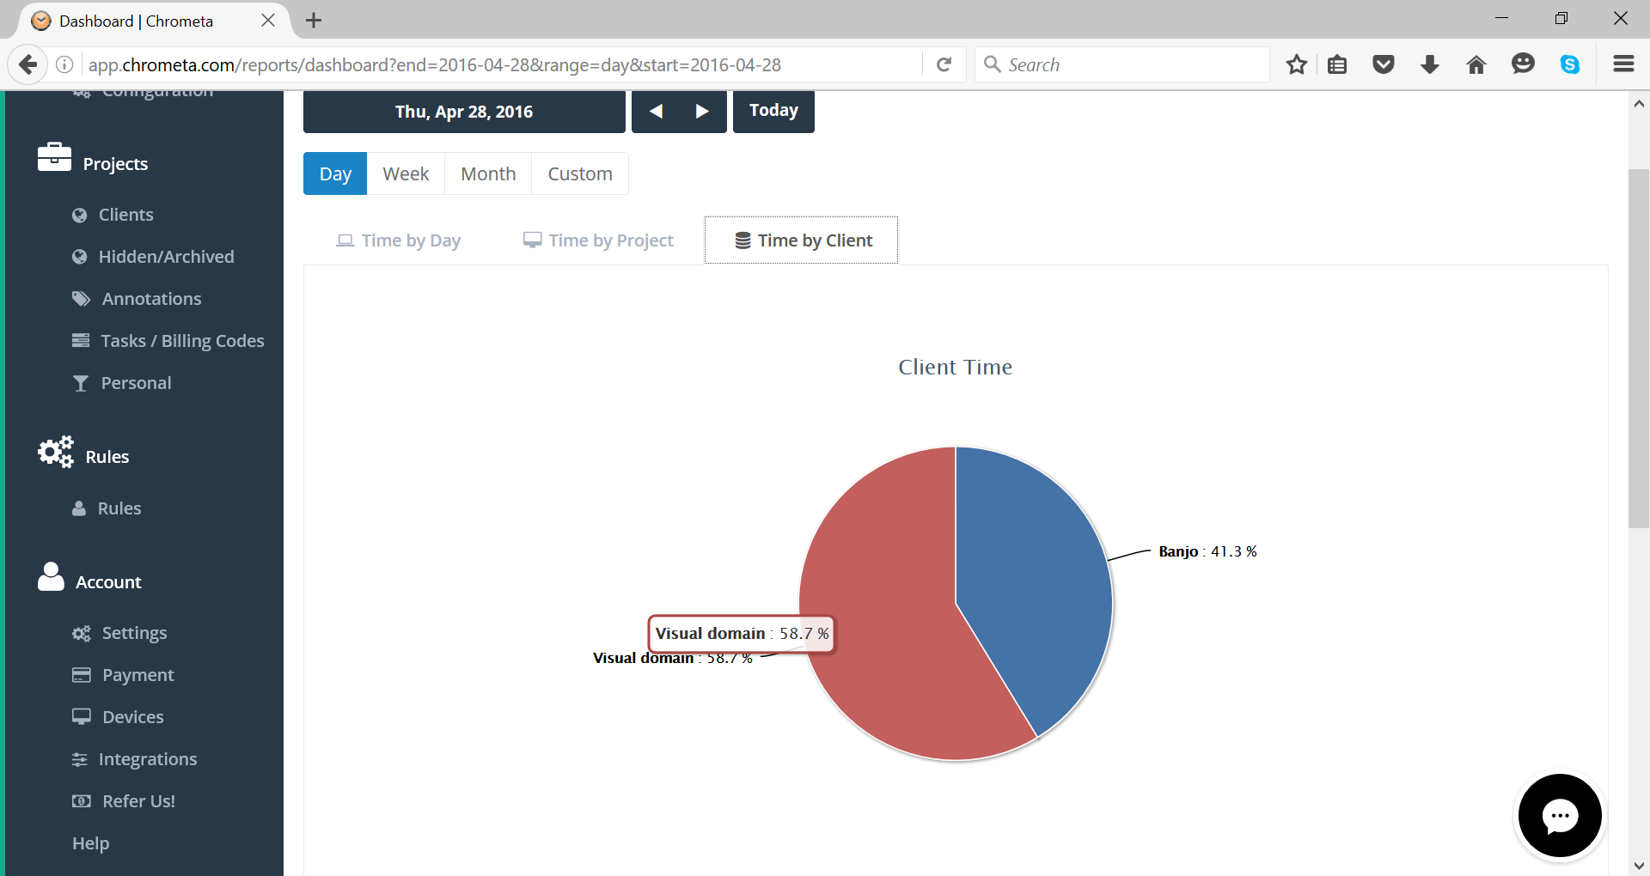
Similar to the above suggest suggest the hover adds new information rather than the same eg number of hours perhaps?.

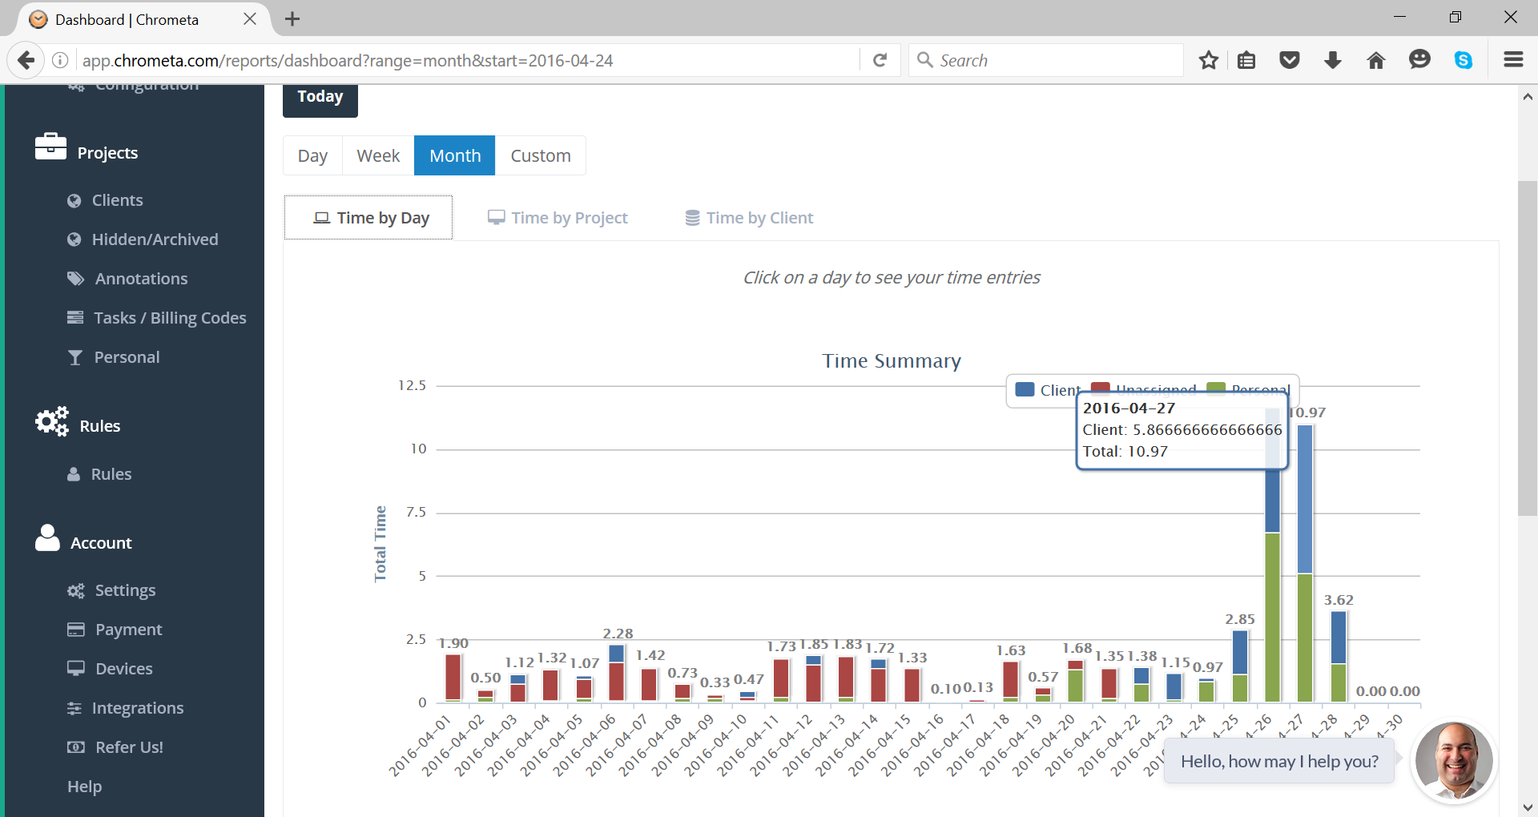
Could be improved with additional secondary axis for capacity utilisation of staff. Also noticed the decimal pt rounding could be kept to consistent 2 decimal pts.
Other suggestions in terms of graphs:
- % utilisation ie how much of the total time was billable vs non billable. If I were managing a team I would like to see their capacity utilisation for example or they goofing off a lot ? Perhaps include this % as a secondary axis to the one which shows the time summary over a period of time ie month or week.
- Ability to export the dashboards into a pdf or word document which can be sent around…if I wanted to do this now I think I need to screen shot it and paste it and crop it.

